Harvesting Energy from Tree Trunks

Nick T. Purcell¹, James D. Stevens², Orlando R. Baiocchi³

University of Washington Tacoma, Washington  
School of Engineering and Technology

Tacoma, WA

[ntp117¹, jamesssf², baiocchi³] @uw.edu

***ABSTRACT:*  With the coming advent of smart devices, remote monitoring and long-range radio communication, there has been an increasing interest in alternative power sources and energy harvesting techniques to prolong indefinitely the smart devices life. One of these alternatives is to take advantage of the Seebeck effect, a natural occurring phenomenon by which the temperature difference between two different types of conductive materials produces a slight voltage difference between them. By leveraging the thermal difference between the core and the surface of a tree trunk there may be enough energy to power IoT devices. This paper discusses the design process of the thermoelectric generators (TEGs) in the energy-harvesting module. It shows how the energy harvesting devices are implemented in the field, as well as the discrete components designed for harvesting energy from a tree. It also shows the proposed solution for future experiments.**

**Keywords: Energy Harvesting, Tree Trunks, Peltier Cell, Seebeck Effect.**

1. Introduction

Modern Wireless Sensor Networks (WSNs) provide data and analytics for safety, efficiency, and other means of monitoring. These sensors require a wide range of voltages to operate and are typically powered by conventional means such as the power grid, batteries, or solar arrays. Sensors must also be connected to a host device which handles the data storage and communication protocols. These host devices require a significantly higher power draw than the sensors. This power cost of the host devices is generally between 3.7 volts and 5 volts.

The purpose of this study is to develop an ecologically sound method of powering environmental sensor networks in remote forest regions using natural renewable energy found in trees. Using previous research on the temperature gradient between the core of a tree and its outside ambient temperature, it is possible to extract energy from tree trunks using the Seebeck effect (Protásio, 2018).

This paper details the implementation and results of two experiments conducted between July 2nd, 2019 and August 13th, 2019. Both trees used were co-located at Joint Base Lewis-McChord, Washington and were approximately the same size. The first device was north facing and the second was south facing. Both energy harvesting devices had full exposure to the sun during the day. The results were promising but much work needs to be done in the way of physical design and employment of the energy harvesting device. An equivalent amount of work must also be done into the research considering variance of trees and climates.

The remainder of this paper is organized as follows: Section 2 introduces the Experimental Energy Harvesting System and thermoelectric generation in details. Section 3 presents the experimental results. Section 4 concludes the paper and gives possible future directions.

1. Energy Harvesting System

Trees around the world attempt to maintain a constant internal temperature of 21.4° Celsius (Helliker, 2008). This study shows the temperature between the core of the tree and the ambient outside environment creates a temperature differential during the rising and falling temperatures throughout the day.

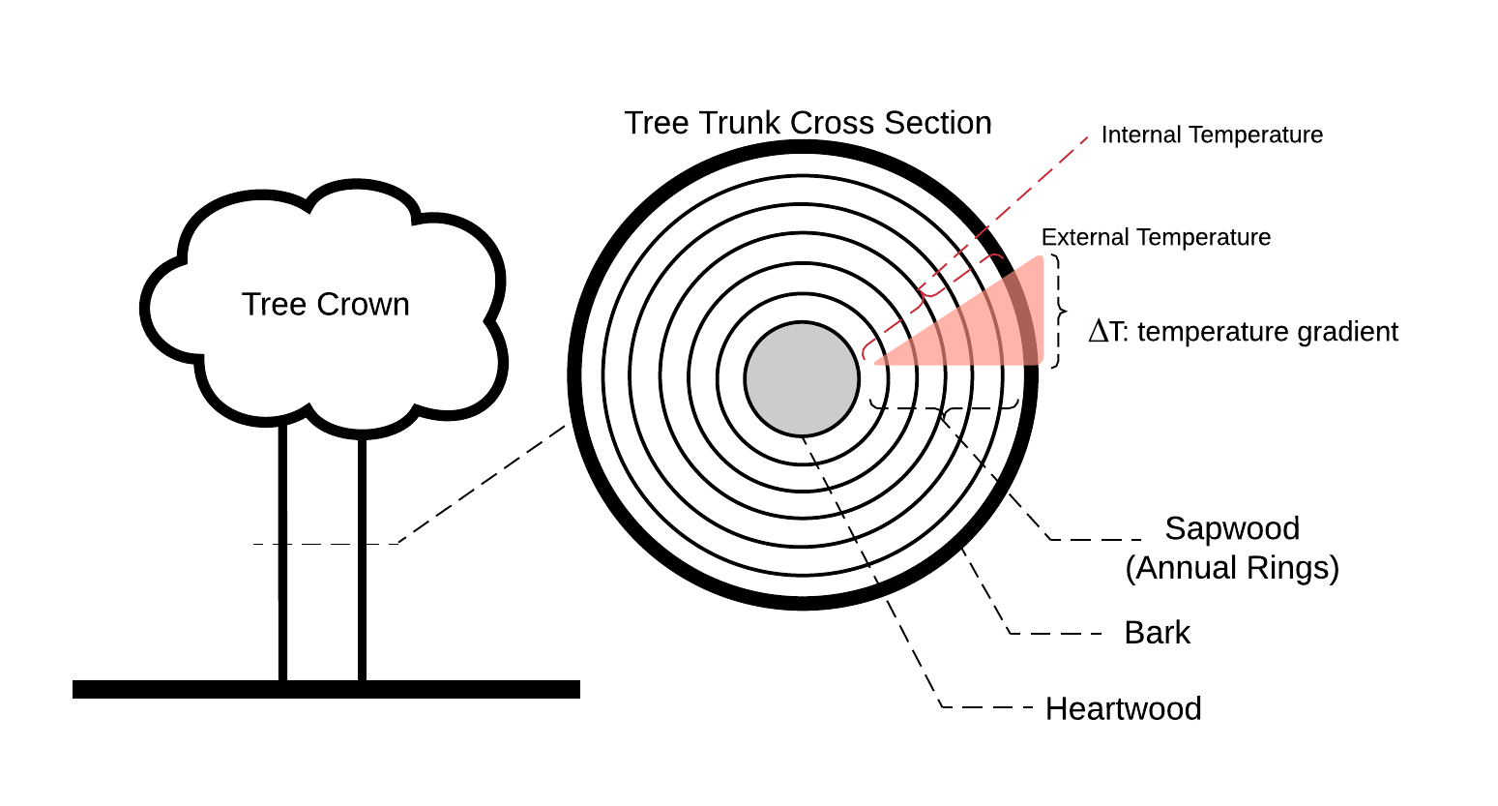

Figure 1. Tree Trunk Cross Section (Nobel, 2009).

One way to take advantage of this is phenomenon to use a Peltier cell. Peltier cells use the Seebeck effect which works on the principle that N-doped metals in series with P-doped metals will induce an electrical current when there is a temperature difference (ΔT) between the surface of the dissimilar metal’s junction.

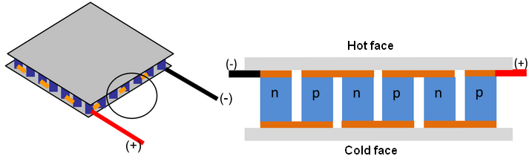

Figure 2. Thermoelectric Module and its internal structure (Source: Nesarajah, 2014).

Peltier cells are manufactured square panels that come in different sizes and quality. In order to leverage its properties with the tree temperature differential, the Peltier cell must have one side at the temperature of the core of the tree and the other side at the ambient outside temperature. The orientation of the Peltier cell was determined by comparing the temperature during the day or night and the internal tree trunk temperature.

$$T_{ Max}=|T_{Int}- T_{Ext}|$$

Equation 1. TMax used to orient the Peltier Cell.

1. Methods

3.1 Open-Circuit Voltage

The goal of the first experiment was to test the open circuit voltage of a TEG subjected to the thermal differential between the core and outside of a tree trunk. A 190mmLx19mmR was driven into the trunk of a healthy 650mm diameter Ponderosa Pine tree until the end of the rod was flush with the bark on the exterior of the trunk. One end of the rod was milled into a point To ensure that there was no air between the rod and the tree, a pilot hole half the diameter and two thirds of the length was drilled into the tree, and the rod was hammered into the hole. It is important for the rod to be sealed in the tree to prevent outside temperature from influencing the temperature of the tree and to prevent pests from getting into the interior of the trunk. Care must be taken not to significantly deform the end of the rod when driving the rod into the tree.

The “Hot” side of the CP60233 20mm TEG was fixed to the end of the Aluminum rod with thermal paste on the face and caulk around the edges to prevent outside temperature from influencing the temperature of the rod. A 20mm heatsink was attached to the “Cold” side of the TEG that was exposed to ambient air. To determine which side would be exposed to ambient temperature, Equation 1 was used. It was determined that during our experiment the greatest temperature gradient would occur at night when ambient hair was cooler than the interior of the tree, so the cool side was exposed to air to maximize voltage during that period.

|  |  |  |
| --- | --- | --- |
| **Time of Day** |  | **July 6th, 2019, JBLM, WA** |
| Day Forecast |  | 4.6° C |
| Night Forecast |  | 5.4° C |

Table 1. TMax found to be greater at night. Cold side will face away from tree.

The positive terminal of the TEG was plugged into an analog input of an Arduino Nano and the negative terminal was plugged into the ground of the Arduino. The ADC on the Arduino was used to convert the open-circuit voltage of the TEG into a digital number, and this number was then sent through the serial port to a Raspberry Pi, where the time of the reading and the voltage reading were saved every second. The Arduino and RPi were powered by a Adafrui power boost connected to a 3000mA hour LION battery, which lasted for approximately 23 hours before the voltage was no longer high enough to sustain the powerboost and the system shut off. The entire module was enclosed in a 3D printed shell. (Figure 4(a)).

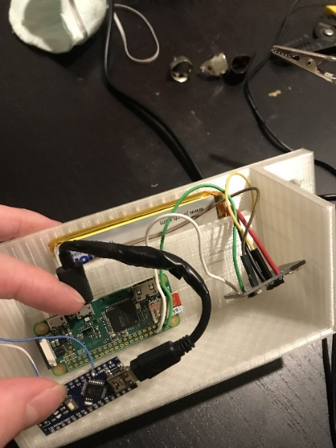 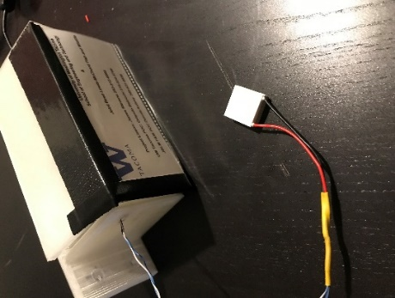

Figure 3. (a) Hardware for first experiment.

The module was installed in a Ponderosa Pine tree at JBLM on July 2nd 2019 at approximately 2PM. The module was turned on and began recording data at 2:39PM. The module ran until the following day at 1:37PM. The data was retrieved and a new battery was installed on July 6th. The module ran and recorded data until 11:11AM the following day. The entire module was retrieved on the 8th of July.

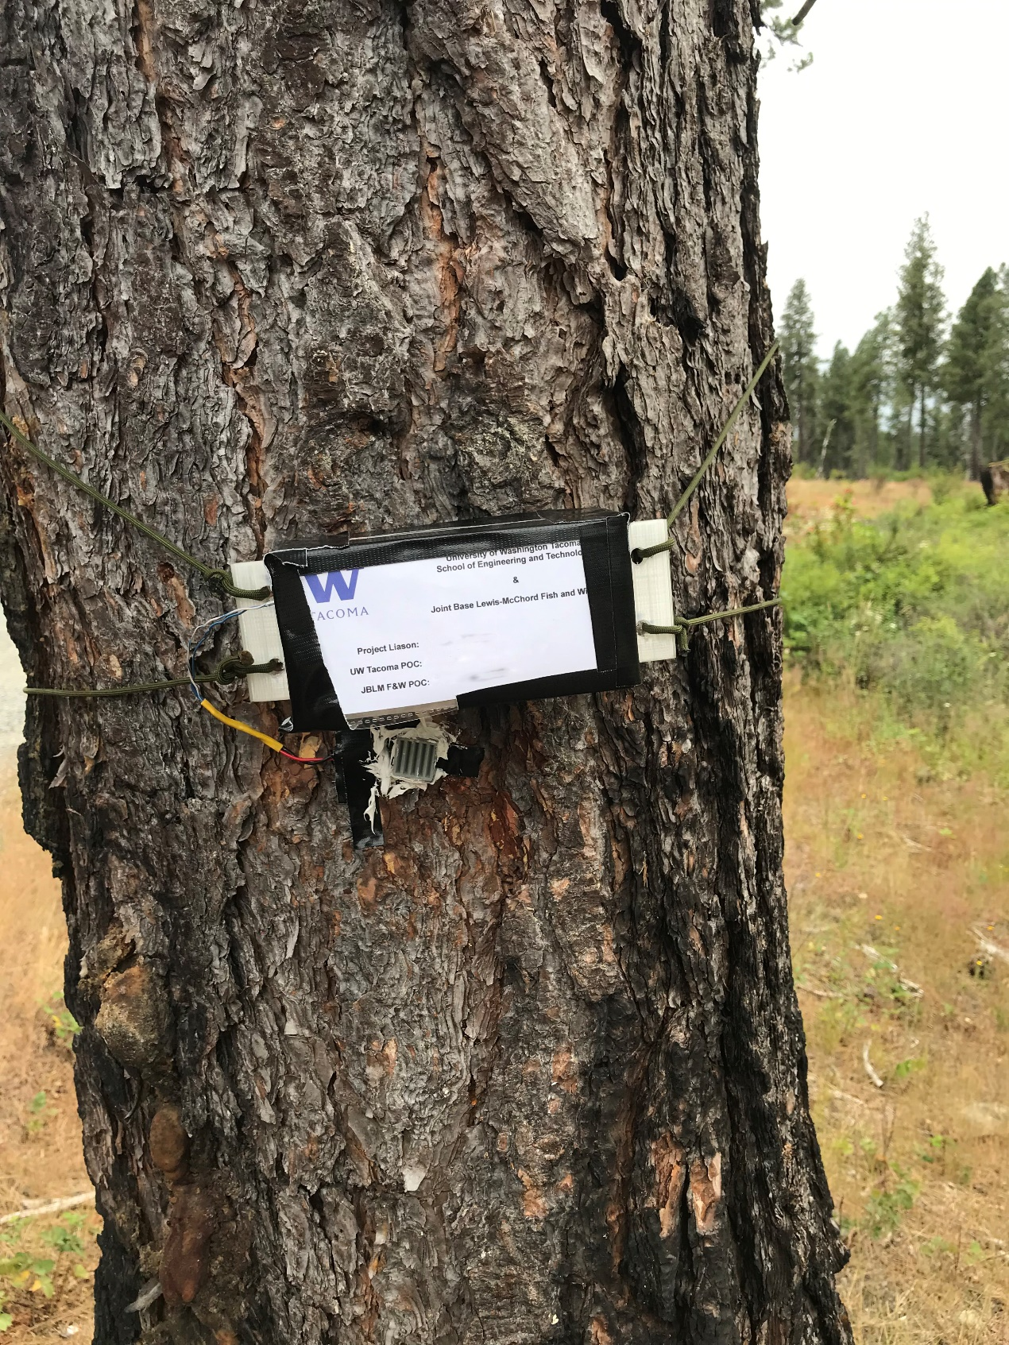

Figure 3. (b) Hardware installed for first experiment (Names & Numbers blurred).

3.2 Voltage Across a 1Ohm Resistor

The goal of the second experiment was to measure the voltage across the TEG when a 1 Ohm a resistor is inserted between the terminals of the TEG. With this data, current and power supplied by the TEG can be found. Much like the previous experiment, an Aluminum rod was embedded in a Ponderosa Pine and a TEG was fixed to the end of the rod. In this experiment a 10mm TEG was selected. The data was saved on a Raspberry Pi Zero and the whole module was powered by an Adafruit Powerboost. A 1 Ohm resistor was chosen to match the .5Ohm resistance of the TEG plus an approximation of the output resistance added by the low thermal conductivity of the tree. Because the low voltage of the TEG a NJU7024 OPAMP was used to amplify the voltage across the resistor to increase the resolution of the ADC. The positive terminal of the TEG was connected to one end of the 1Ohm resistor, and the negative terminal was connected to the opposite end of the resistor and to ground on the Adafruit Powerboost, which was being used as a single ended supply for the OPAMP. The positive terminal of the TEG was the input of both an inverting and noninverting amplifier on two of the four OPAMPs on the IC. The outputs of the OPAMPs were connected to tow of the input terminals of the MCP3008 ADC, which was chosen rather than the Arduino Nano to conserve power. In this way, the voltage across the TEG would be amplified and converted to binary no matter the direction of the heat differential across the TEG.

To measure the thermal differential across the TEG, one LM35 temperature sensor was embedded in aluminum the rod and another was fixed to the bark of the tree near the TEG. The Temperature sensors were powered by the powerboost, and the sense voltage outputs were plugged into the input terminals of the MCP3008. To keep accurate time the RCF8523 RTC was installed on the I2C pins on the Raspberry Pi. To Increase the duration of the experiment, a ICM7555 timer in astable mode was installed in the module. The output of the timer was plugged into the enable pin on the powerboost. The 7555 timer circuit was built such that the enable signal would be on for approximately 3 minutes, and off for approximately 16 minutes. When the enable signal turns on, the powerboost turns on and supplies all of the components with power. The raspberry pi saves data from the MCP3008 for two minutes before shutting off. After the enable signal turns off, the powerboost turns off and no power is supplied to any of the components, except for the timer which is powered by the battery itself. This extended the battery life of the module to over three days. The module was soldered to a pin board and placed in a plastic container that was fixed to the tree.

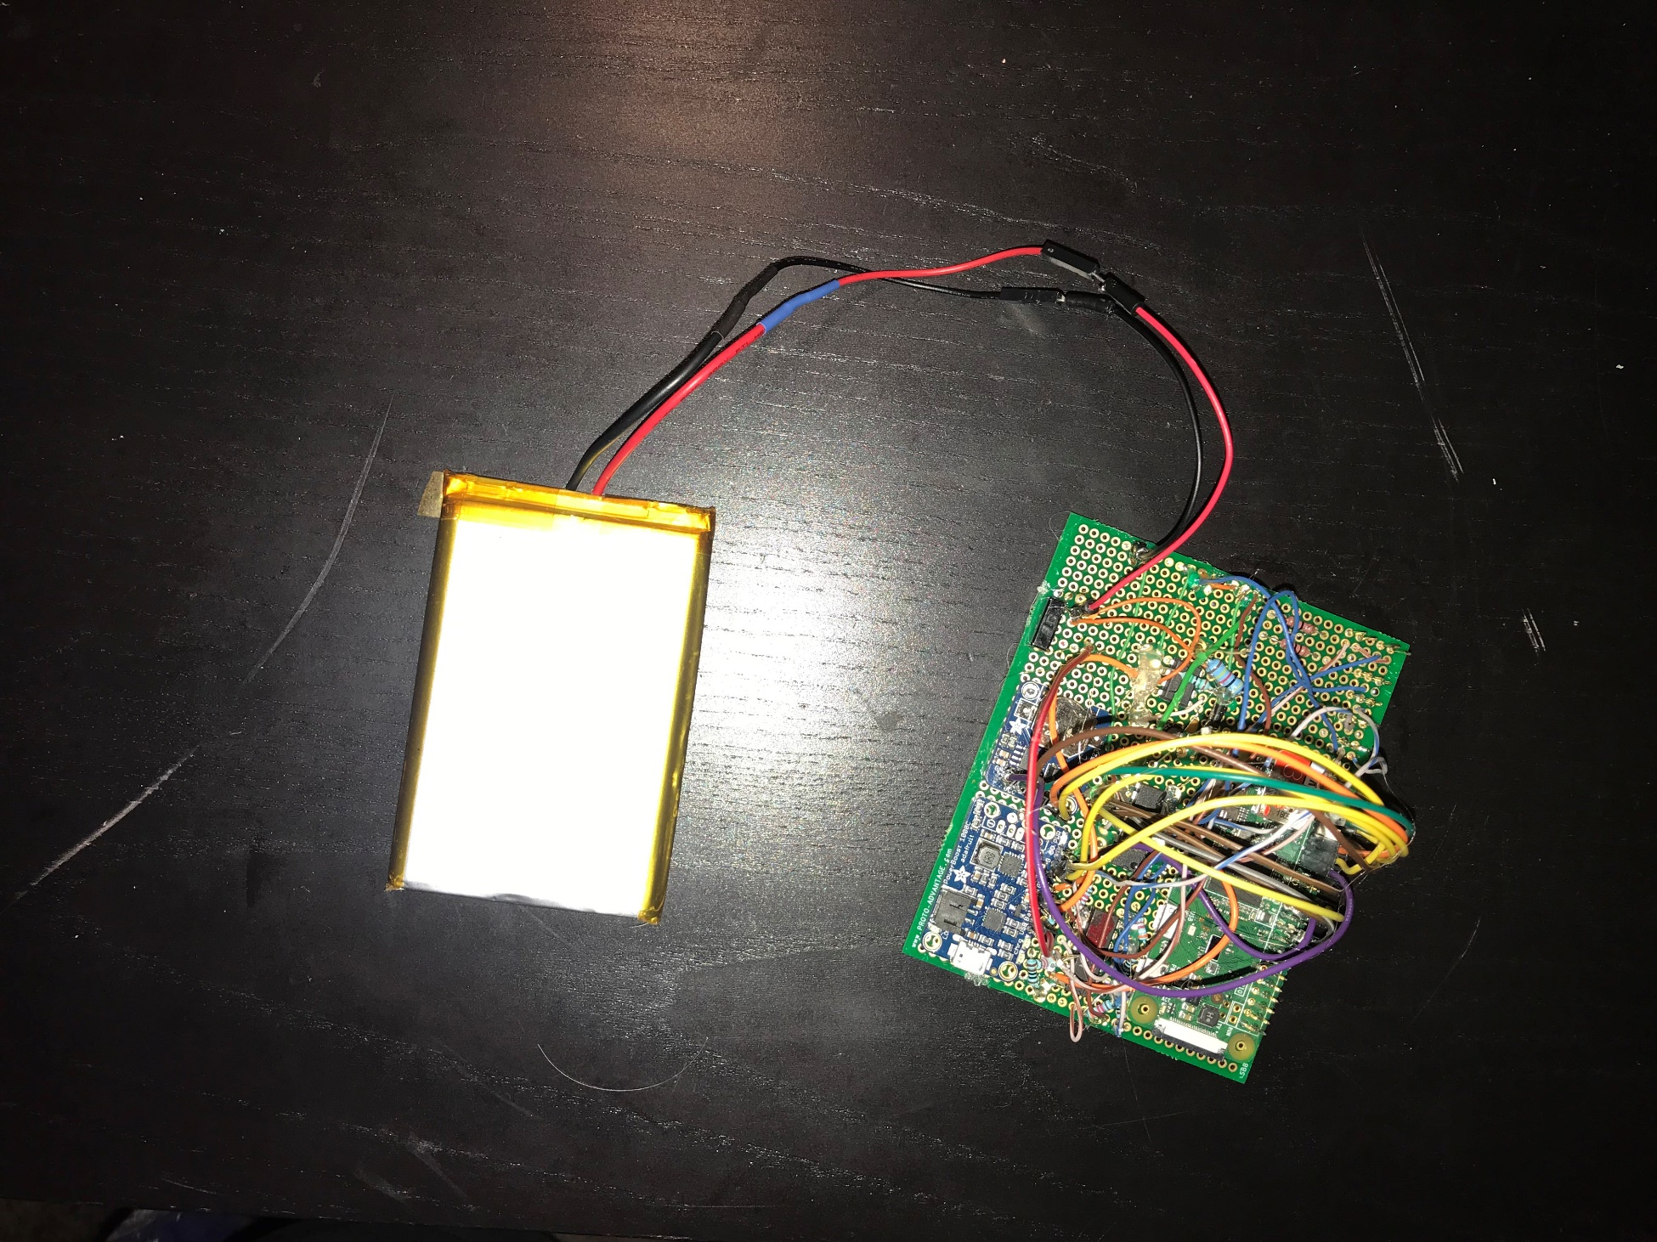

Figure 6. Hardware of Experiment 2: Raspberry Pi, RTC, 555 Timer, On-Off Switch, Powerboost 1000c, OpAmp, ADC, 1 Ohm Resistors

The accuracy of the OPAMPs and TEGs was measured after the module was built. The voltage saved by the raspberry pi was compared to the voltage found by a lab digital multi-meter. The TEG was held against warm lab equipment and removed to change the voltage generated by the TEG. The maximum difference between the recorded and actual voltage was .280mV, and the average difference was .098mV.

Figure 5. TEG voltage read by lab equipment and voltage recorded by Raspberry Pi

The module was installed in a Ponderosa Pine near the tree used for the first experiment. The module was turned on and began saving data at approximately 12:30PM on August 13th, 2019. The battery was changed periodically over the course of the week and the data was collected on the 20th.

1. Experimental results

4.1 Open-Circuit Voltage

During the first session, the module measured a spike in voltage across the terminals of the TEG starting at approximately 00:00 on 7/3/2019 that lasted form approximately 10 hours. The average voltage was 2.16mV, with a maximum voltage measure of 4.09mV. During all other hours of the first experimental session, no voltage was measured. This is due to the limitations of the Arduino Nano; the Arduino Nano ADC can only convert voltages greater than 0V. During the second session the module measured a voltage spike starting at approximately 23:00 on 7/6/2019 which lasted for approximately 11 hours. The average voltage was 2.01mV, and the maximum voltage measured was 4.52mV. Local temperature data was acquired for the duration of the second experimental session. The temperature spike occurred after a 4°C temperature drop, from 19°C to 15°C, and ended when the temperature rose back to 19°C.

Figure 6a. Voltage vs Time Graph of Experiment 1 session 1.

Figure 6b. Voltage and Temperature vs Time Graph of Experiment 1 session 2.

4.1 Open-Circuit Voltage

The temperature sensors ran for approximately two days before they began to fail, while the rest of the module ran as expected for the duration of the experiment. The temperature of the rod averaged at 22.6°C for the duration of the experiment. The temperature of the rod increased by a few degrees when the ambient temperature rose to 45°C, and fell a few degrees when the ambient temperature fell to 14°C, which is consistent with the results found by Helliker. By comparing the temperature data to the voltage data, it was found that the voltage across the TEG rises by approximately .259mV for every degree Celsius difference between the ambient temperature and the temperature of the tree when the ambient air is warmer than the interior of the tree, and the voltage rises by approximately .207mV in the opposite direction when the ambient air is cooler than the interior of the tree. The maximum recorded temperature during the day was 6.8mV, and the maximum recorded at night was 3.789mV

Figure 7. Probability density for stochastic portion of TEG voltage

There are two components of the TEG voltage, the component linearly proportional to the temperature difference, and a stochastic component. The stochastic component closely matches a Gaussian distribution with a mean of 0 and a variance of .17mV. However, as this is within the margin of error found in section 3.2, this stochastic portion is influenced by the ADC. By using a more accurate ADC and higher quality OPAMPs, the effect they have on the readings would subside. Despite this, there is undoubtedly a stochastic component to the voltage across the TEG.

Figure 8.a Experiment 2 – Voltage

Figure 8.b Experiment 2 – Temperature

1. Conclusions and possible future directions

The results of both experiments were promising considering the simplistic apparatus design. With a more efficient design and better materials the results should see some improvement. Future research should consider the characteristics of each tree species available and the environment they inhabit. Tree density, fluid-dynamics, size, and temperature difference are among some properties to consider.

Currently available TEGs vary in sizes and efficiency. Future experiments should test these against varying diameters of rods. Surface area vs resistance should be researched. Depth increased the temperature difference between the tree and the ambient temperature (Protásio, 2018). Thus, one might consider an aluminum rod that has TEG’s in series, inserted at intervals inside the tree to increase the yield. Custom design work will need to be done in order to make sure the rod and all attached components stay undamaged during the installation process. A problem may arise where there will not be enough compartmentalization between each TEG and thus reduces the efficacy. However, if depth is a factor this may be worth exploring rather than a single TEG at the end of the rod.

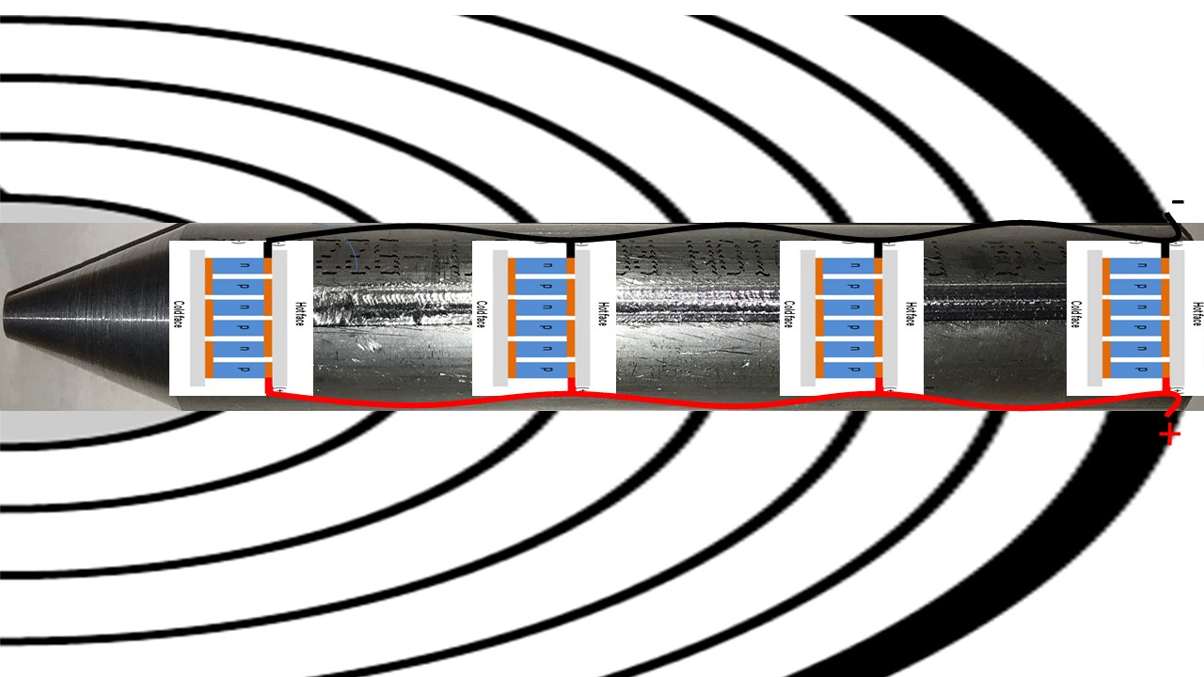

Figure 9. Possible Future Experiment 1.

Research was conducted into thermocouples as they have a cylindrical shape more advantageous to the research at hand; however, these are designed to operate as temperature sensors rather than generators and are not as efficient as TEGs in voltage generation. However, thermocouple wire is available and could be useful for a proof-of-concept design as illustrated in Figure 9.

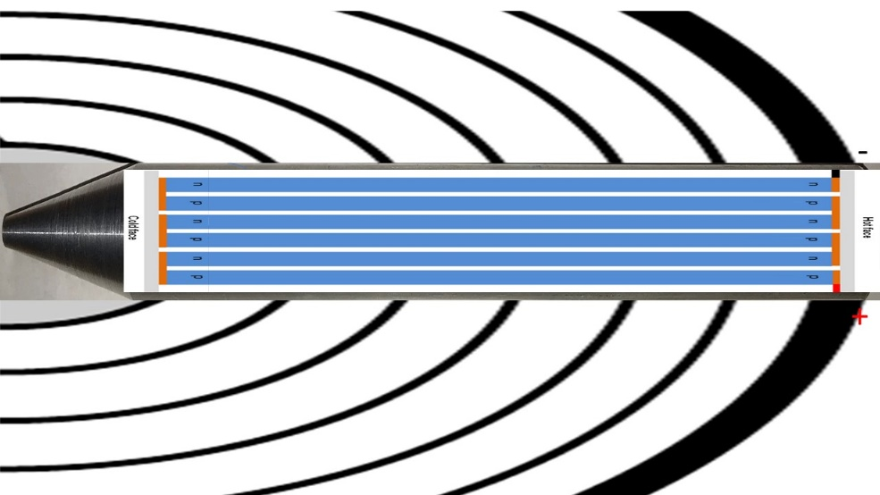

Figure 10. Possible Future Experiment 2.

The second experiment resulted in a maximum of 5mV across a 1-ohm load which is not enough to power current day sensors and transmit the data. The next step is to use adapted circuits to reach the required threshold of usable power. A Joule-Thief circuit will store the energy in capacitors and release it in intervals allowing for higher potentials. Impedance matching and capacitor leakage will be the main hurdles to overcome.

If the energy harvester is the sole source of power, given the current data, it may be possible to power sensors with extremely low power communication chips that communicate with a central node. This central node would likely be powered by more conventional means and transmit for a longer distance. If energy harvesting is not enough for the given sensor nodes, an energy-harvesting device may be used to trickle charge a battery at such a rate to sustain the battery long term.

Lastly, another viable option is to install multiple energy harvesters in a single tree and connect them in series. More research needs be done regarding tress ability to sustain these rods and mechanisms.

References

Cleonilson Protásio de Souza, Fabrício B. S. Carvalho, Filype A. N. Silva, Hening A. Andrade, Nathália de V. Silva, On Harvesting Energy from Tree Trunks for Environmental Monitoring, 2018

Helliker, Brent R. and Richter, Suzanna L. Subtropical to boreal convergence of tree-leaf temperatures.  Nature.  Vol 454|24 July 2008| doi:10.1038/nature07031

Nobel, Park S. Physicochemical and Environmental Plant Physiology. URL: https://books.google.com.br/books?id=3wMBwxGIqDIC, 2009 Elsevier Science.

Nesarajah, M.; Felgner, F.; Frey, G.: Modeling and Simulation of a Thermoelectric Energy Harvesting System for Control Design Purposes. Proceedings of the 16th International Conference on Mechatronics - Mechatronika (ME), IEEE, Brno, Czech Republic, pp. 170-177, Dec. 2014. <DOI: 10.1109/MECHATRONIKA.2014.7018254>.